Case Study No: 1
Experiment Title: Demonstration of basics of JavaScript program.

Case Study Title: Create a webpage for college department and link the student information page with it and write a Java Script Program to Display "Welcome to SIT Nagpur" in an alert Box.

Software/ Tools Required: VS Code (text editor), HTML, CSS, JavaScript.

Case Study Program Code:
Index.html –
<!DOCTYPE html>
<html>
<head>
<title>JS Practical 1</title>
<link rel="stylesheet" href="style.css">

<script>
window.onload = function () {
alert("Welcome to SIT Nagpur");
};

function showWelcome() {
let name = document.getElementById("name").value;
let age = document.getElementById("age").value;
let email = document.getElementById("email").value;

document.getElementById("output").innerHTML =
"<h2>Welcome, " + name + "!</h2>" +
"<p>Your Age is: " + age + "</p>" +
"<p>Your Email is: " + email + "</p>";

console.log("User Name: " + name);
console.log("User Age: " + age);
console.log("User Email: " + email);
console.warn("This is a warning message.");
console.error("This is an error message (Demo Purpose).");
}

function resetOutput() {
document.getElementById("output").innerHTML = "";
}
</script>
</head>

<body>
<h1>User Information</h1>

<label>Enter Name:</label><br>
<input type="text" id="name" placeholder="Enter Name"><br><br>

<label>Enter Age:</label><br>
<input type="number" id="age" placeholder="Enter Age"><br><br>

<label>Enter Email:</label><br>
<input type="email" id="email" placeholder="Enter Email"><br><br>

<button onclick="showWelcome();">
Submit
</button>

<button onclick="resetOutput();">
Clear Output
</button>

<hr>

<div id="output"></div>

<footer style="margin-top:40px; text-align:center; font-size:16px">
<hr>
<p><strong>Created by:</strong> Ritisha Naigaonkar-045, A2 Batch</p>
</footer>

<script src="script.js"></script>

</body>
</html>

Script.js –

function greet() {
alert("Your form has been submitted!");
}

Style.css –
html {
min-height: 100%;
background-color: gray;
}

body {
font-family: system-ui, -apple-system, sans-serif;
color: darkslategray;
max-width: 420px;
margin: 50px auto;
padding: 30px;
border: 1px solid lightgray;
border-radius: 10px;
background-color: white;
}

h1 {
color: darkblue;
text-align: center;
margin-top: 0;
font-size: 24px;
}

label {
font-weight: bold;
color: dimgray;
font-size: 14px;
}

input {
width: 100%;
padding: 10px;
margin-top: 5px;
margin-bottom: 15px;
border: 1px solid lightgray;
border-radius: 6px;
box-sizing: border-box;
font-size: 14px;
}

input:focus {
border-color: deepskyblue;
outline: none;
}

button {
width: 48%;
padding: 12px;
background-color: dodgerblue;
color: white;
border: none;
border-radius: 6px;
font-weight: bold;
font-size: 14px;
cursor: pointer;
margin-right: 2%;
}

button:last-of-type {
background-color: crimson;
margin-right: 0;
}

button:hover {
opacity: 0.9;
}

hr {
border: 0;
height: 1px;
background-color: lightgray;
margin: 20px 0;
}

#output {
padding: 15px;
background-color: mintcream;
border-left: 5px solid forestgreen;
border-radius: 6px;
}

#output h2 {
color: forestgreen;
margin-top: 0;
font-size: 18px;
}

#output p {
color: darkslategray;
margin-bottom: 0;
font-size: 14px;
}

Output:
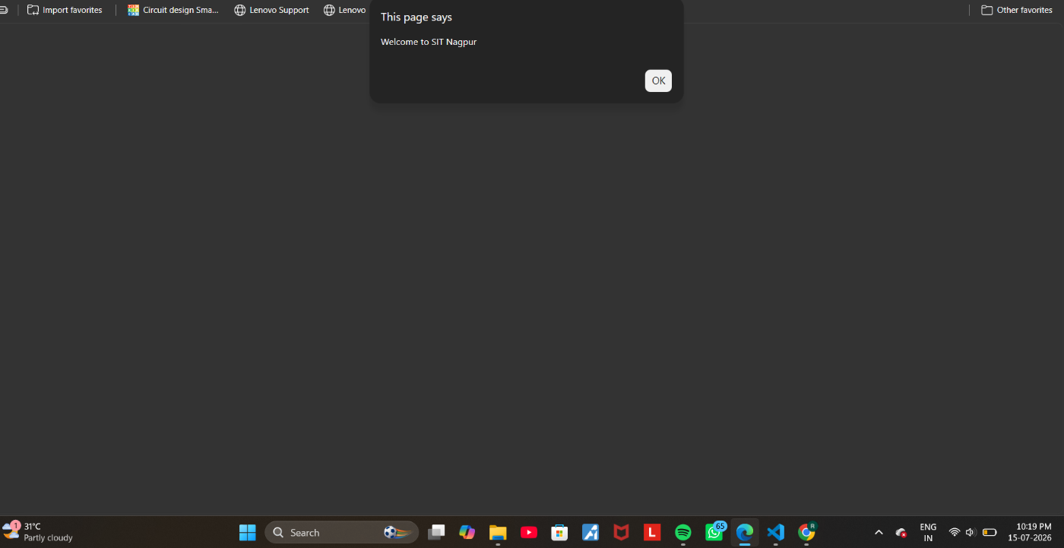

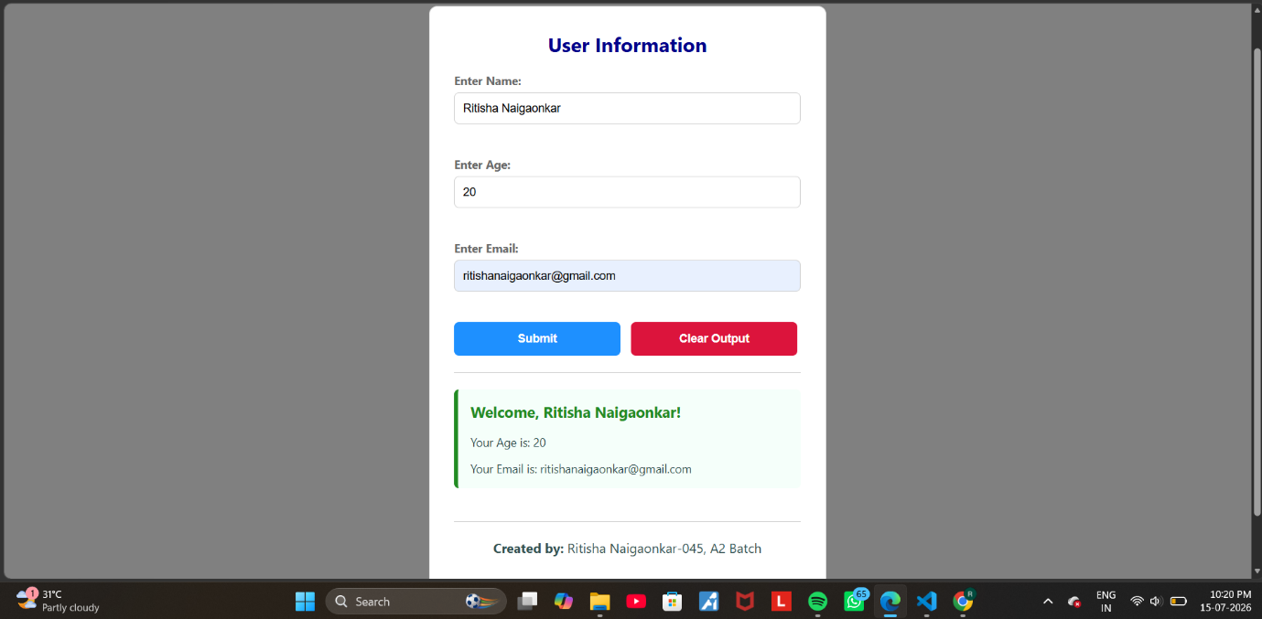

Result/ Conclusion: Thus a working website has been created using HTML, JS and its UI was styled using CSS.

Ritisha Naigaonkar, Sem5-A, 24070521045

